https://www.youtube.com/watch?v=DnGKgBeqGos

Connectivity \ ActivityStarted

Notifier

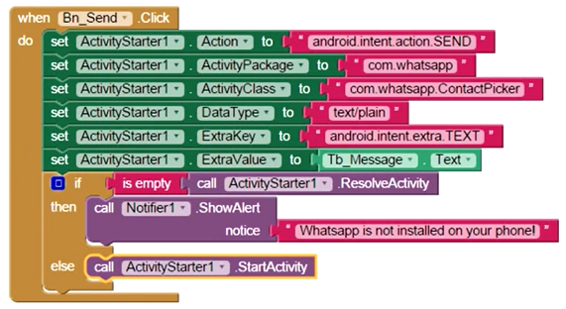

Se abrirá com.whatsapp.ContactPicker para escoger

Si desea una persona fija debe darle numero ( ¿??? )

= = = = =

Intent i = **new** Intent(Intent.***ACTION_SEND***).setData(Uri.*parse*(**"content://com.android.contacts/data/"** + **"64281048@s.whatsapp.net"**));

i.setPackage(**"com.whatsapp"**);  
 i.setType(**"text/plain"**);

**if** (i != **null**) {  
 String text = **"YOUR TEXT HERE"**;  
 i.putExtra(Intent.***EXTRA_TEXT***, text);  
 startActivity(i);  
 } **else** {  
 Toast.*makeText*(getApplicationContext(), **"WhatsApp not Installed"**, Toast.***LENGTH_SHORT***).show();  
 }

Intent i = **new** Intent(Intent.***ACTION_SEND***).setData(Uri.*parse*(**"content://com.android.contacts/data/+50364281048@s.whatsapp.net"**));

Intent i = **new** Intent(Intent.***ACTION_SEND***).setData(Uri.*parse*(**"content://com.android.contacts/data/+503 7237 6533@s.whatsapp.net"**));

i.setPackage(**"com.whatsapp"**);  
i.setType(**"text/plain"**);  
**if** (i != **null**) {  
  
 i.putExtra(Intent.***EXTRA_SUBJECT***, **"Subject"**);  
 i.putExtra(Intent.***EXTRA_TEXT***, **"I'm the body."**);  
 startActivity(i);

}

|  |  |
| --- | --- |
| Pide seleccionar contacto | Intent i = **new** Intent(Intent.***ACTION_SEND***).setData(Uri.*parse*(**"content://com.android.contacts/data/72376533@s.whatsapp.net"**));  **if** (i != **null**) {  i.setPackage(**"com.whatsapp"**);  i.setType(**"text/plain"**);   i.putExtra(Intent.***EXTRA_SUBJECT***, **"Subject"**);  i.putExtra(Intent.***EXTRA_TEXT***, **"I'm the body."**);  startActivity(i);  }  **else** {  Toast.*makeText*(getApplicationContext(), **"WhatsApp not Installed"**,  Toast.***LENGTH_SHORT***).show(); } |
| No asigna mensaje | Uri uri = Uri.*parse*(**"smsto: 72376533"**); Intent i = **new** Intent(Intent.***ACTION_SENDTO***, uri);  */* i.setFlags(Intent.FLAG_ACTIVITY_NEW_TASK); */* i.putExtra(**"sms_body"**, **"Cool!!"**); i.setPackage(**"com.whatsapp"**); startActivity(i); |
| Select chooser | Intent i = new Intent(Intent.ACTION_SEND);  i.setType("text/plain");  PackageInfo info =  pm.getPackageInfo("com.whatsapp", PackageManager.GET_META_DATA);  i.setPackage("com.whatsapp");  i.putExtra(Intent.EXTRA_TEXT, "YOUR TEXT HERE");  startActivity(Intent.createChooser(i, "Share with")); |
| Open whatsapp with a given number | Uri uri = Uri.parse("smsto:" + number);  Intent i = new Intent(Intent.ACTION_SENDTO, uri);  i.setPackage("com.whatsapp");  startActivity(Intent.createChooser(i, "")); |